Poetry Terms
Alliteration
Allusion
Antithesis
Approximate rhyme
Assonance
Ballad
Blank verse
Consonance
Couplet
Direct metaphor
End rhyme
Free verse
Hyberbole
Imagery
Internal rhyme
Oxymoron
Metaphor
Mood
Onomatopoeia
Personification
Hyberbole
Rhyme
Rhyme scheme
Satire
Simile
Stanza
Symbol
Synecdoche
Tone
Verse
How to Read a Poem:

Read with a pencil
- Read a poem with a pencil in your hand.
- Mark it up; write in the margins; react to it; get involved with it. Circle important, or striking, or repeated words. Draw lines to connect related ideas. Mark difficult or confusing words, lines, and passages.
- Read through the poem, several times if you can, both silently and aloud.
Examine the basic subject of the poem
- Consider the title of the poem carefully. What does it tell you about the poem's subject, tone, and genre? What does it promise? (After having read the poem, you will want to come back to the title in order to consider further its relationship with the poem.)
- What is your initial impression of the poem's subject? Try writing out an answer to the question, "What is this poem about?"--and then return to this question throughout your analysis. Push yourself to be precise; aim for more than just a vague impression of the poem. What is the author's attitude toward his or her subject?
- What is the poem's basic situation? What is going on in it? Who is talking? To whom? Under what circumstances? Where? About what? Why? Is a story being told? Is something--tangible or intangible--being described? What specifically can you point to in the poem to support your answers?
- Because a poem is highly compressed, it may help you to try to unfold it by paraphrasing the poem aloud, moving line by line through it. If the poem is written in sentences, can you figure out what the subject of each one is? The verb? The object of the verb? What a modifier refers to? Try to untie any syntactic knots.
- Is the poem built on a comparison or analogy? If so, how is the comparison appropriate? How are the two things alike? How different?
- What is the author's attitude toward his subject? Serious? Reverent? Ironic? Satiric? Ambivalent? Hostile? Humorous? Detached? Witty?
- Does the poem appeal to a reader's intellect? Emotions? Reason?
Consider the context of the poem
- Are there any allusions to other literary or historical figures or events? How do these add to the poem? How are they appropriate?
- What do you know about this poet? About the age in which he or she wrote this poem? About other works by the same author?

Study the form of the poem
- Consider the sound and rhythm of the poem. Is there a metrical pattern? If so, how regular is it? Does the poet use rhyme? What do the meter and rhyme emphasize? Is there any alliteration? Assonance? Onomatopoeia? How do these relate to the poem's meaning? What effect do they create in the poem?
- Are there divisions within the poem? Marked by stanzas? By rhyme? By shifts in subject? By shifts in perspective? How do these parts relate to each other? How are they appropriate for this poem?
- How are the ideas in the poem ordered? Is there a progression of some sort? From simple to complex? From outer to inner? From past to present? From one place to another? Is there a climax of any sort?
- What are the form and genre of this poem? What should you expect from such a poem? How does the poet use the form?
Look at the word choice of the poem
- One way to see the action in a poem is to list all its verbs. What do they tell you about the poem?
- Are there difficult or confusing words? Even if you are only the slightest bit unsure about the meaning of a word, look it up in a good dictionary. If you are reading poetry written before the twentieth century, learn to use the Oxford English Dictionary, which can tell you how a word's definition and usage have changed over time. Be sure that you determine how a word is being used--as a noun, verb, adjective, adverb--so that you can find its appropriate meaning. Be sure also to consider various possible meanings of a word and be alert to subtle differences between words. A good poet uses language very carefully; as a good reader you in turn must be equally sensitive to the implications of word choice.
- What mood is evoked in the poem? How is this accomplished? Consider the ways in which not only the meanings of words but also their sound and the poem's rhythms help to create its mood.
- Is the language in the poem abstract or concrete? How is this appropriate to the poem's subject?
- Are there any consistent patterns of words? For example, are there several references to flowers, or water, or politics, or religion in the poem? Look for groups of similar words.
- Does the poet use figurative language? Are there metaphors in the poem? Similes? Is there any personification? Consider the appropriateness of such comparisons. Try to see why the poet chose a particular metaphor as opposed to other possible ones. Is there a pattern of any sort to the metaphors? Is there any metonymy in the poem? Synecdoche? Hyperbole? Oxymoron? Paradox? A dictionary of literary terms may be helpful here.
Finishing Up
- Ask, finally, about the poem, "So what?" What does it do? What does it say? What is its purpose?

A Dog's Prayer
--Beth Norman Harris

Treat me kindly, my beloved master, for no heart in all the world is more grateful for kindness than the loving heart of me.

Do not break my spirit with a stick, for though I should lick your hand between the blows, your patience and understanding will more quickly teach me the things you would have me do.
Speak to me often, for your voice is the world's sweetest music, as you must know by the fierce wagging of my tail when your footstep falls upon my waiting ear.
When it is cold and wet, please take me inside... for I am now a domesticated animal, no longer used to bitter elements... and I ask no greater glory than the privilege of sitting at your feet beside the hearth... though had you no home, I would rather follow you through ice and snow than rest upon the softest pillow in the warmest home in all the land... for you are my god... and I am your devoted worshiper.
Keep my pan filled with fresh water, for although I should not reproach you were it dry, I cannot tell you when I suffer thirst. Feed me clean food, that I may stay well, to romp and play and do your bidding, to walk by your side, and stand ready, willing and able to protect you with my life, should your life be in danger.
And, beloved master, should the Great Master see fit to deprive me of my health or sight, do not turn me away from you. Rather hold me gently in your arms as skilled hands grant me the merciful boon of eternal rest...and I will leave you knowing with the last breath I drew, my fate was ever safest in your hands.
I AM Poem
Below are line-by-line directions for writing this kind of poem:
#1. I am
#2. Three nouns about which you have strong feelings. Begin each with a capital letter.
#3. A complete sentence about two things that you like.
#4. Three nouns that describe what you like to see in other people; end with "are important to me."
Capitalize each noun.
#5. A sentence containing a positive thought or feeling. It can tell what you find acceptable in yourself.
#6.-#7. Sentence in which you show something negative in yourself or others, however the sentence must end by showing that out of something BAD can come GOOD. Use the word "but" to link the bad and good.
#8.-#9.-#10. Each line is a short sentence relating something about which you have strong feelings--likes or dislikes. They do not have to relate to each other or to the previous lines you have written.
#11. End with "This is me" or "I am."
I am
Life, Hope, Living
I care very much about the world and life on it.
Honesty is important to me.
Optimism is important to me.
Unselfishness is important to me.
Hospitality is a good thing.
Meanness is bad, but can be goot to get people
off your back.
The world is getting weaker.
The longer the days the more beautiful they are.
People are too negative.
I am.
Below is the line-by-line set-up for a different version of the "I Am..." poem:
1st Stanza
I am (two special characteristics you have)
I wonder (something you are actually curious about)
I hear (an imaginary sound)
I see (an imaginary sight)
I want (an actual desire)
I am (the first line of the poem is repeated)
Stanza 2
I pretend (something you really pretend to do)
I feel (a feeling about something imaginary)
I touch (something you imagine you touch)
I worry (a worry that is real to you)
I cry (something that makes you very sad)
I am (the first line of the poem is repeated)
Stanza 3
I understand (something you know is true)
I say (something you believe in)
I dream (a dream you actually have)
I try (something you make an effort to do)
I hope (something you really hope for)
I am (the first line of the poem is repeated)
I AM
I am the wine and the future
I wonder how many ripples I will have to swim
I hear the trickle of time in a bitter bottle
I see the translucent red drain from the wine
I want the sweet satin liquid to stain my tongue
I am the wine and the future.
I pretend to entertain the glowing embers
I feel the dew that sours the grapes
I touch the vine that grows new life
I worry the drunkard may speak the truth
I cry the dewdrop tears on the winery walls
I am the wine and the future.
I understand the dust on the bottle
I say it only makes it sweeter with time
I dream the sponge cork may never be replaced by lips
I try to glimmer the crack in my glass container
I hope the sun-faded label never creases for lost identity
I am the wine and the future.

Acrostic Poem

An acrostic/alphabet poem consists of using the letters of a word, which is the subject of the poem, to begin each line of the poem.
Please pay attention
Or
Everyone will be lost
Monday during the test over poetry.

Cinquain
Cinquain is a five-line poem, which is constructed with both syllable and part of speech constraints.
- Line 1: Write a noun of one syllable.
- Line 2: Write two adjectives of four syllables.
- Line 3: Write three verbs of six syllables.
- Line 4: Write a short thought about the noun using eight syllables.
- Line 5: Repeat the noun or use a synonym with two syllables.

Lie
Wrongness, falsehood
Hurts, punishes, darkens
Makes matters worse and worse for me
Untruth

Diamonte

A symmetrical or diamonté poem is another form of the part of speech poem. Its difference is that it allows movement of the subject from the beginning to end of the poem.
- Line 1: Write one noun which is subject #1.
- Line 2: Write down two adjectives describing subject #1.
- Line 3: Write down three participles or verbs ending in "ing" telling about subject #1.
- Line 4: Write down two nouns related to subject #1 and two nouns related to subject #2.
- Line 5: Write down three participles or verbs ending in "ing" telling about subject #2.
- Line 6: Write down two adjectives describing subject #2.
- Line 7: Write one noun which is subject #2 and usually the opposite of subject #1.

Diamonte sample:

Cat
clever, cuddly
crouching, pouncing, purring
meow, feline, canine, bark
running, jumping, wagging
lovable, smart
Dog

Haiku

Haiku poems are characterized by content, language, and form. Of the three elements, form is the least important. The content of haiku poems is primarily nature. Usually there are no similies or metaphors, nor are there many adjectives. The most common form is three lines, the first and third being the same length and the middle one being a little longer. In English-speaking countries this has been translated into a 5/7/5 syllable structure.

An afternoon breeze The warmth on my skin.
expels cold air, along with Fire falls beneath the trees.
the fallen brown leaves. I see the sun set.

TANKA
A tanka is a mood piece, usually about love, seasons, sadness, or how short life is. Tankas use strong images and often have literary devices such as simile and metaphor. A tanka is short and usually has only five lines. Instead of counting syllables, you count ACCENTED syllables. The following pattern of ACCENTED syllables works well in English for a tanka: 2/3/2/3/3. Some claim the tanka contains 5/7/5/7/7 syllables. Actually, you can use either method for determining the sounds in this kind of poem.
Beautiful mountains
Rivers with cold, cold water.
White cold snow on rocks
Trees over the place with frost
White sparkly snow everywhere.

      

The leaves change colour
When the fall winds start to blow,
Yellow, orange and brown
Are the colours of fall leaves,
Slowly falling from the trees.

Concrete Poem

A shaped or concrete poem is visual poetry. The shape or form is as much a part of the poem as the words. The words are arranged in such a way that they suggest a picture of the subject of the poem.
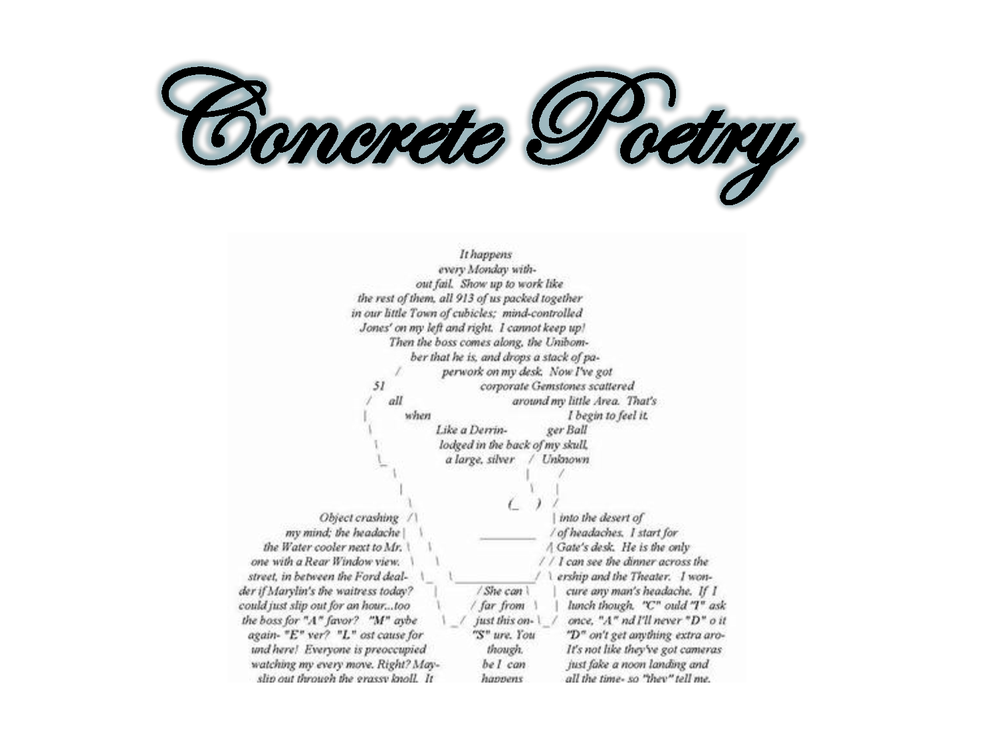It happens every Monday without fail.. Show up to work like the rest of them, all 913 of us packed together in our little Town of cubicles; mind-controlled Jones’ on my left and right. I cannot keep up! Then the boss comes along, the Unibomber that he is, and drops a stack of paperwork on my desk. Now I’ve got 51 corporate Gemstones scattered all around my little area. That’s when I begin to feel it. Like a Derringer Ball lodged in the back of my skull, a large, silver unknown object crashing into the the desert of my mind; the headache of headaches. I start for the water cooler next to Mr. Gate’s desk. He is the only one with a rear window view. I can see the diner across the street, in between the Ford dealership and the Theater. I wonder if Marylin’s the waitress today? She can cure any man’s headache. If I could just slip out for an hour…too far from lunch though. “C”ould “I” ask the boss for “A” favor? “M”aybe just this once, “A”nd I’ll never “D”o it again – “E”ver? “L”ost cause for “S”ure. You “D”on’t get anything extra around here! Everyone is preoccupied though. It’s not like they’ve got cameras watching my every move, right? Maybe I can just fake a noon landing and slip out through the grassy knoll. It happens all the time – so they tell me.

Credo Poem
In the movie Bull Durham Kevin Costner's character is asked what he believes in. His answer provides us with a poetic format. By following the formula below, tell what you believe in.
CREDO
I believe in the _________________________
the____________________________________
the____________________________________
the____________________________________
the____________________________________
But (something you don't believe in, i.e. ("but the novels of Susan Sontag are self-indulgent, over-rated")
I believe in____________________________
I believe in____________________________
I believe in____________________________
And I believe in_________________________________(longest)
Example: CREDO
I believe in the wisdom of elders,
the influence of peer pressure,
the importance of success,
the evil that exists in money,
the effectiveness of hard work,
dedication, courage, strength.
But the belief that you don't have to strive
for your goals is just outrageous.
I believe in the truth that will set you free,
I believe in love that will conquer all,
I believe in respect for others,
Courtesy, politeness, gratitude.
And I believe in the fact that tomorrow
isn't promised to you.
Just Because...
These poems ask you to describe yourself in the first line of the poem. The next three lines in each stanza tell what you are NOT. The final line restates the first line and adds a tag directing the reader to do something.
Student Examples:
Just because I'm scared
Don't laught and giggle behind my head
Don't kid and play when I'm not there
Still ask me because I might play
Just because I'm scared
It doesn't mean I can't do it
It doesn't give you the right to talk about me
It doesn't stop me from having fun
Just because I'm scared
Still tell me everything you did
Can't wait until I get big
Just because I'm scared -- please try to be my friend
      
Just because I'm an only child
I'm not a freak
I'm not shy
Just because I'm an only child
I'm not lonely
I'm not selfish
I'm not spoiled
Just because I'm an only child
I know I'm not perfect
I can't always be the best friend
I'm not a nerd
Just because I'm an only child -- let me be me.

Blotz Poem

A blotz poem is designed to describe an object, which is not necessarily real. It places an emphasis on alliteration.
- Line 1: Name your creature. (This is ___)
- Line 2: Tell where your creature lives. All words begin with the first letter of the creature's name and should list at least four places.
- Line 3: Tell what your creature eats. Use the same first letter and include at least four items.
- Line 4: Tell what your creature likes. Use the same first letter and include at least four items.
- Line 5: Tell something about your creature. Use the same first letter and include at least three items.
- Line 6: Tell about something your creature did to you.

This is a teacherarian.
Teacherarians live in Turkish towers on top of telegraph transmitters in Tibet only on Tuesdays.
Teacherarians eat tortoise toes, tangy tarts, tender toast, and tuna.
Teacherarians throw temper tantrums, torment students, try on toupees, and twiddle their thumbs.
Teacherarians teach trigonometry, enjoy tapestry, and like tanning their temples.
This teacherarian told me to tape up my mouth. It tortured me and tore out my teeth.

Five Senses

A five senses poem describes an emotion or idea. Its emphasis is on the different ways in which the senses can be used to describe.
- Line 1: Tell what color an emotion or idea is.
- Line 2: Tell what the emotion tastes like.
- Line 3: Tell what the emotion sounds like.
- Line 4: Tell what the emotion smells like.
- Line 5: Tell what the emotion looks like.
- Line 6: Tell what the emotion makes you feel like.
Fall is red and yellow.
It tastes like chicken soup.
It sounds like wind through the trees.
And smells like warm wood smoke.
It looks like the soul of the devil
And makes you feel like the angels in heaven
Limerick
A limerick is a humorous five-line poem, which consists of a rhyme scheme of aabba. Lines 1, 2, and 5 have eight to ten syllables and lines 3 and 4 have five syllables. It has a long history as verse if not poetry and is frequently risqué.
There was once a lady in Champlain
Who said she had nothing to gain.
She gave it a try.
And said she was spry.
But crashed when she took the afternoon train.

A UFO went to land in Dakota
But the brakes didn't work one iota.
It didn't take long
To decide what was wrong
Seems the space ship was made by Toyota!

I once knew a word I forgot
That means, "I am sorry we met
And I wish you the same."
It sounds like your name
But I haven't remembered it yet.

There once was an ape in a zoo
Who looked out through the bars and saw YOU!
Do you think it's fair
To give poor apes a scare?
I think it's a mean thing to do.

There was a young fellow who thought
Very little, but thought it a lot.
Then at long last he knew
What he wanted to do,
But before he could start, he forgot.

Poetry Annotation

- Your first step for this assignment is to find a poem you think is worth analyzing. It can be song lyrics.
- Find the poem on the internet and copy and paste it into a word document.
- Try your best to fit it on one page without making the font smaller than 12pt. Delete repeated choruses and unnecessary space.
- Make sure the title and author is at the top of the page in bold.
- Center the poem/lyrics so you have sufficient margins on both sides.

Using the following guidelines, annotate the poem you have chosen in the margins.

1) Choose one of these Literary Criticism techniques and thoroughly answer the questions on the back of the lyrics page:

Marxism: Who is at the top of the social ladder? Who is at the bottom? Where is there evidence of power struggle in the text?
Reader Response: Knowing that it’s not the same for all readers, what is you personal interpretation of the text? How does it make you feel? How can you relate it to your own experiences?
Psychological: Look for struggle in relationships and analyze them. What is the “deeper” motivation for the characters to act as they do?
Feminism: How are women portrayed in the story? In what ways to characters fit gender stereotypes or not fit them?

2) At the top of the page, summarize the poem in 1-2 sentences.

3) Based on the poem, what are two philosophical beliefs held by the author? Indicate these with a star next to the lines in the poem that support your claim.

4) Annotate instances of 4 of the following literary terms. Be specific by a) underlining the example, b) labeling each instance, and c) answering the questions in the margins.

Personification (What is being personified?)
Alliteration (What is the repeated sound? What is its effect?)
Metaphor/Simile (What is being compared? What does the comparison mean?)
Imagery (To which of the 5 senses does the imagery appeal?)
Tone (What is it? Underline the lines that best convey tone.)
Characterization (What does this reveal about the character’s personality? Not nec. the same as
author’s)
Allusion (What is the reference?)
Hyperbole (What is being exaggerated?)

5) At the bottom of the page, write a sentence explaining the theme of the poem.

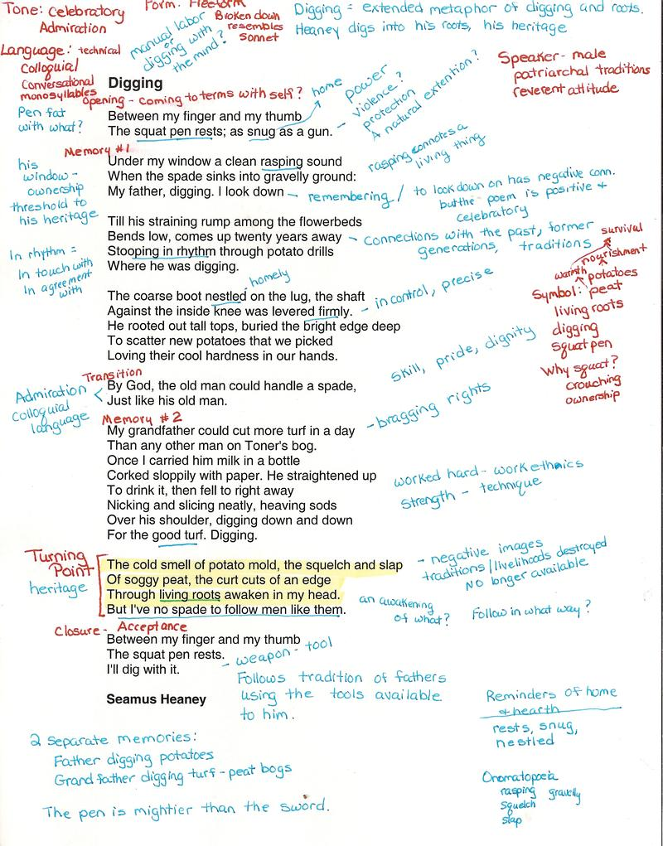

The Lost Generation
--Jonathan Reed

I am part of a lost generation.
And I refuse to believe that
I can change the world.
I realize this may be a shock, but
“Happiness comes from within”
Is a lie, and
“Money will make me happy”
So in thirty years, I will tell my children
They are not the most important thing in my life.
My employer will know that
I have my priorities straight because
Work
Is more important than
Family
I tell you this:
Once upon a time
Families stayed together
But this will not be true in my era.
This is a quick fix society
Experts tell me
Thirty years from now, I will be celebrating the tenth anniversary of my divorce.
I do not concede that
I will live in a country of my own making.
In the future,
Environmental destruction will be the norm.
No longer can it be said that
My peers and I care about this Earth.
It will be evident that
My generation is apathetic and lethargic.
It is foolish to presume that
There is hope.
And all of this will come true unless we reverse it.

